` Abstract 1

Introduction to NLP 2

History and Development of NLP 3

Key Concepts of NLP 3

Applications of NLP 3

Challenges and Future Directions in NLP 4

Conclusion 5

References 5

NLP- Research Paper

Group Pheobe

10/22/2024

Period 1

--------------------------------------------------------------------------------------------------------------------

1.Abstract- Tyrese

2.Introduction to Natural Language Processing - Jaden

3.History and Development of NLP - Jaden

4.Key Concepts in NLP- Kayla

5.Applications of NLP- Amadeus

6.Challenges and Future Directions in NLP - Anthony

7.Conclusion - Tyrese

8.References - All / Everyone

-----------------------------------------------------------------------------------------------------------------

# Abstract

(NLP) is a field where computer science and artificial intelligence are intersection and focused on giving computers to comprehend how humans behave and come close to replicating that. Despite advances in this field, ambiguity, bias. This study aims to understand the history uses and what Natural language processors (NLP) can do for us in the future. We employed AI, LLM (large language models), articles, and other websites to investigate this issue. Our results demonstrate that NLP helps computers understand and create human language. It still has issues like misunderstanding and bias, but it is getting better at handling multiple languages Clearer. These findings prove that NLP can change the world as we know it and add connections to cultures, people, and languages, making work a lot easier. NLP powers voice assistants, real-time translation, and social media sentiment analysis. As it improves, our interactions with tech will feel more natural. But we need to watch out for biases and aim for fair, unbiased systems. This research contributes to healthcare, education, opening new avenues for diagnosis and treatment or personalized learning for students with specialized learning needs.

# Introduction to NLP

(NLP) is a field where computer science and artificial intelligence are intersection and focused on giving computers to comprehend how humans behave and come close to replicating that. It focuses on enabling computers to understand, interpret, and generate human language in a way that is both meaningful and useful. The goal of NLP is to help computers understand language as well as we do. talking in a positive sentiment or negative sentiment or being a serious statement or sarcastic statement. Natural Language Processing studies interactions between humans and computers to find ways for computers to process written and spoken words like how humans do. NLP techniques include voice assistants like Amazon’s Alexa and Apple’s Siri utilize NLP to listen to user queries and find answers. They also do things like machine translation and text-filtering. NLP also helps with speech recognition, which seeks to analyze spoken language into words, turning sound into text and vice versa. NLP is us humans trying to get computers to understand unstructured text, unstructured text is the way we normally speak.

# History and Development of NLP

The roots of NLP can be traced back to the 1950s, when the field of AI began to emerge. In 1950, Alan Turing proposed the Turing Test as a measure of machine intelligence, which involved natural language conversation. Early attempts at machine/computer translation between Russian and English began in the 1950s, marking one of the first functional applications of NLP. In 1966, ELIZA was created by Joseph Weizenbaum. ELIZA was one of the first chatbots that could engage in dialogue using pattern matching. In the 60s and 70s NLP research focused on developing rule-based systems. Augmented Transition Networks, a formal model for natural language grammar, emerged in the 1970s. In 1970, Terry Winograd developed SHRDLU, which is natural language understanding program that could interpret and respond to English commands in a limited block world. In the 1980’s, IBM researchers developed statistical models for computer translation, which laid the foundation for modern NLP. In 2013, word embedding techniques like Word2Vec improved NLP model performance. In 2022, a generative AI chatbot based on the GPT-3.5 model, quickly growing in popularity, and reaching over 1 million users (about the population of Delaware) within just five days of its release, it was called ChatGPT.

# Key Concepts of NLP

4. Key Concepts in NLP  
Tokenization- Tokenization is breaking text into smaller Lexemes called “tokens” which is essential for permitting computers to understand and process human language significantly. Distinct languages and use cases insist on different tokenization strategies.

These different tokens can be:

words: “I love candy” → [ “I,” “love,” “candy”],

sub words: “catching” → [“catch”” “ing”],

characters: “Greetings” [ “G,” “r,” “e,” “e,” “t,” “i,” “n,” “g,” “s”]

Part-of-Speech Tagging is a fundamental task in Natural Language Processing (NLP) that involves assigning grammatical categories to words in a text. This process helps machines understand the structure and meaning of sentences by identifying the role each word plays.

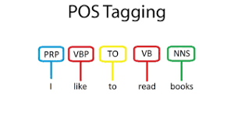

Named Entity Recognition

NER is the process of locating and categorizing specific elements in text into predefined categories such as person names, organizations, locations, time expressions, quantities, monetary values, and percentages. Detect entities in text

Classify them into predefined categories. This task enables machines to understand and extract structured information from unstructured text, which is crucial for various NLP applications.

Sentiment Analysis...

Sentiment analysis, also known as opinion mining, is an NLP approach that identifies the

* Determining opinions about products, services, or ideas
* Extracting subjective information from text

Categorizing text as positive, negative, or neutral

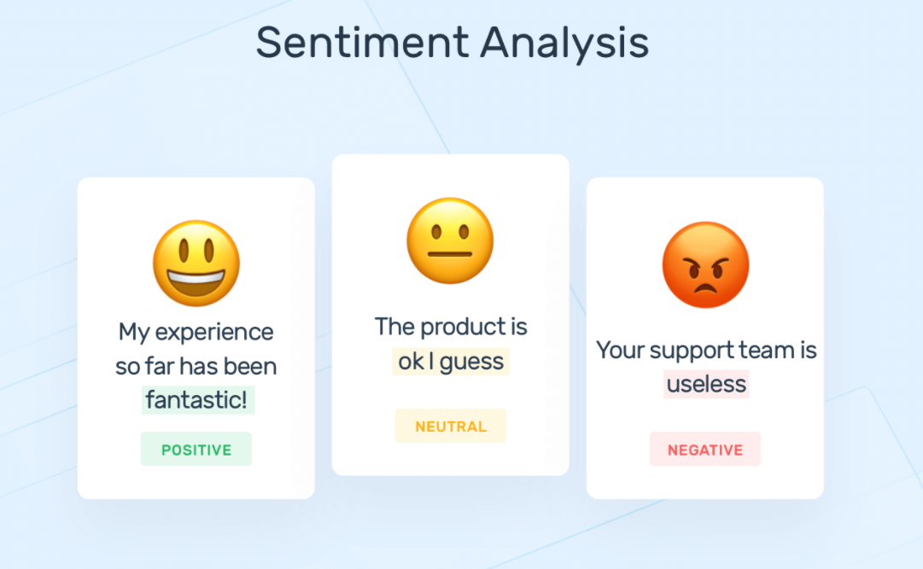

Semantics is understanding the meaning of words and sentences. It allows interpretation of

language beyond literal meanings. Sentence Breaking is Identifying and segmenting individual sentences within text. It crucial for tasks like machine translation and summarization. Morphology in NLP is the computational analysis of word structures, focusing on breaking down words into their constituent parts (like roots, prefixes, and suffixes) and understanding their roles and meanings. Predictive Text in NLP refers to the technology that anticipates and suggests the next word or phrase a user is likely to type based on the context of their input and learned patterns. The core techniques are:

1. Language Modeling: Predicts word sequences using statistical and neural models
2. Machine Learning: Employs RNNs and Transformers for sequential data processing
3. Context Analysis: Examines surrounding words for relevant predictions
4. Personalization: Adapts to individual writing styles
5. Multilingual Support: Enables cross-language predictions

# Applications of NLP

Machine Translation- Machine Translation (MT) is Translation of phrases from one language to another, preserving the meaning of the text that was inputted and creating a fluent output language. For Example, Translating Chinese to English is a Function that uses Machine

translation. Mutiple translators that use this function of NLP such as Google Translate,

Microsoft Translate and Alexa. There are many types of Machine translation That use similar

Functions such as: Rule-Based MT, Statistical MT, Neural MT, and Hybrid MT. Lets

dive Deeper Into their functions. Rule based MT is the translation that relies on sources to

ensure a translation that is precise to the content show. This is done by a software analyzing

text input by a user then converts the information into the language targeted with use of

grammar rules and dictionaries used in that language. Statistical Machine Translation rather than

relying on sources or linguistic rules instead it uses machine learning, which extensively

examines human translations. When given tasks of translating new sources the software makes a

hypothesis on the likelihood of words or phrases being used in association of the target

language. Neural Machine based on the human brain contains of a network of interconnected

nodes that form an information system. Data that is input passes through these nodes and forms

an output. Neural Machine Translation uses neural networks to process datasets using nodes to

change source text to the target text which is obtained at the output node.

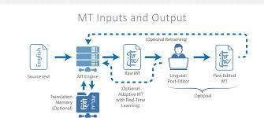

# Chatbots And Virtual Assistants

**Chatbots** are programs that interact with users in human link conversations using textual

or auditory means. Functions of chatbots include Offering Instructions to customers to finish tasks or share information of products or contact details from customers such as setting appointments or creating a service portal to support customers in real time. Examples for Chatbots include Google Assistant Amazon Alexa and Facebooks Messenger.

**Virtual Assistants** are personal software-based Agents that assist in Completing daily tasks such as, shopping Cooking Cleaning and other simple tasks Virtual Assistants are designed to assist in the daily commute, they help in a human-like manner. Examples of Assistants include Siri, Cortana, Alexa and google assistant.

# Challenges and Future Directions in NLP

The field of Natural Language Processing (NLP) has seen significant advancements, yet it continues to face large and notable challenges. One of the largest challenges in NLP is ambiguity, as most words and sentences often have multiple and different meanings. Understanding the correct interpretation and context of a saying may be difficult and remains a complex task between NLP systems. Another challenge for NLP’s could be bias in their training data. Bias in NLP training data is a large issue that can lead to inaccurate and potentially harmful information when these AI models are deployed, some sources of bias can include unbalanced datasets which can over represent certain groups and perspectives while underrepresenting certain groups and perspective. Historical prejudices, showing data collected from past sources has a higher probability of containing outdated and discriminatory views and biases. On the other hand, a promising future direction for NLP lies in the development of advanced multilingual language models Multilingual language models while being overly complex with there being over 7000 languages spoken across the world, researchers are developing more sophisticated models which will be able to generate text and understand the multitude of languages and will enable better communications between people with different linguistic backgrounds.

# Conclusion

This study has explored the evolution, current applications, and future potential of Natural Language Processing (NLP). Our findings prove that NLP has made significant strides in enabling computers to understand and generate human language, despite ongoing challenges with ambiguity and bias. The research highlights NLP's transformative impact across various sectors, including voice assistants, real-time translation services, enabling sentiment analysis, enhancing healthcare, and Revolutionizing education with personalized learning experiences

As NLP technology continues to advance, it promises to make human-computer interactions more natural and intuitive. However, addressing inherent biases and ensuring fairness in NLP systems remains a critical challenge. The integration of external knowledge and the development of multilingual models are emerging trends that will shape the future of NLP. These advancements have the potential to break down language barriers and foster greater cross-cultural understanding.

In conclusion, while NLP still faces challenges, its ongoing development opens new avenues for connecting cultures, streamlining work processes, and enhancing various aspects of daily life. As we move forward, it is crucial to balance the pursuit of technological advancement with ethical considerations to ensure that NLP systems are fair, unbiased, and beneficial to all users.

**--------------------------------------------------------------------------------------------------------------------**

# References

Builtin.com

Deeplearning.ai

funginstitute.berkeley.edu

johnsnowlabs.com

Deeplearing.com

Talentedladiesclub.com

startus-insights.com

nlp-technique.com

*The Stanford NLP Group*. (n.d.). <https://nlp.stanford.edu/projects/mt.shtml>

<https://www.ixopay.com/en/news/what-is-nlp-natural-language-processing-tokenization>

<https://wandb.ai/mostafaibrahim17/ml-articles/reports/An-introduction-to-tokenization-in-natural-language-processing--Vmlldzo3NTM4MzE5>

<https://www.geeksforgeeks.org/nlp-how-tokenizing-text-sentence-words-works/>

Newman-Griffis, D., Lehman, J. F., Rosé, C., & Hochheiser, H. (2021, June 1). *Translational NLP: A New Paradigm and General Principles for Natural Language Processing Research*. <https://pmc.ncbi.nlm.nih.gov/articles/PMC8223521/>

GeeksforGeeks. (2024, January 11). *Machine Translation in AI*. GeeksforGeeks. <https://www.geeksforgeeks.org/machine-translation-of-languages-in-artificial-intelligence/>

<https://www.ixopay.com/en/news/what-is-nlp-natural-language-processing-tokenization>

[.](https://wandb.ai/mostafaibrahim17/ml-articles/reports/An-introduction-to-tokenization-in-natural-language-processing--Vmlldzo3NTM4MzE5)

<https://www.geeksforgeeks.org/nlp-how-tokenizing-text-sentence-words-works/>

Bafna, S. (2023, April 23). Chatbots vs. Virtual Assistants – What’s the Difference? –. . . *Customer Service Blog from HappyFox – Improve Customer Service & Experience*. <https://blog.happyfox.com/chatbots-vs-virtual-assistants-whats-the-difference/>